Practical - 9

**AIM :**  **Performing basics commands to interact with Kubernetes.**

The objective of this lab is to familiarize yourself with basic commands to interact with a Kubernetes cluster. You will learn how to perform essential operations such as deploying pods, checking cluster status, and inspecting resources.

**Step 1:** Verify `kubectl` Configuration

kubectl config current-context



**Step 2:** List Nodes

kubectl get nodes



**Step 3:** Create a Deployment

kubectl create deployment nginx-deployment --image=nginx



kubectl get deployments



**Step 4:** List Pods

kubectl get pods



**Step 5:** Access Pod Logs

kubectl logs nginx-deployment-6d6565499c-rxvct

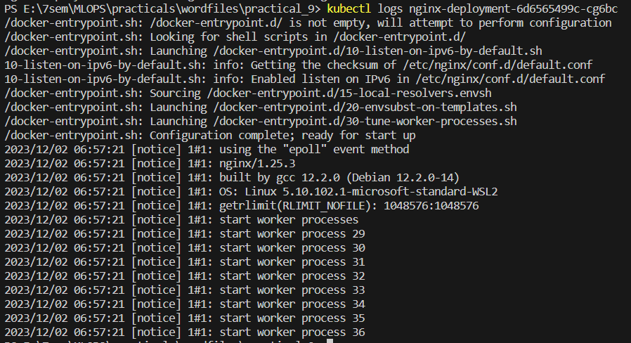

**Step 6:** Expose Deployment as a Service

kubectl expose deployment nginx-deployment --port=80 --type=NodePort --name=nginx-service

kubectl expose deployment nginx-deployment --port=80 --type=NodePort



**Step 7:** List Services

kubectl get services

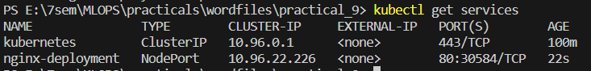

**Step 8:** Access the NGINX Service

kubectl describe service nginx-deployment

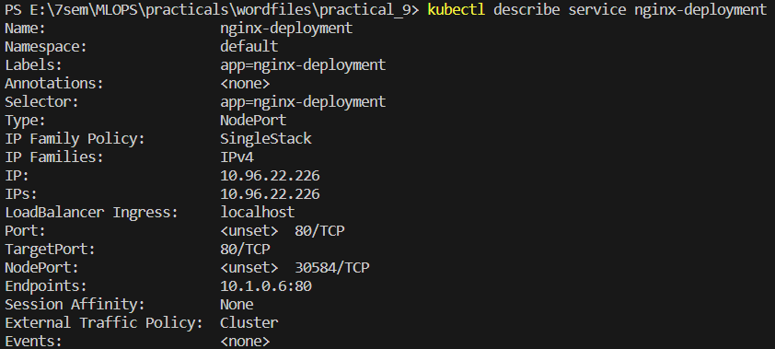

**Step 9:** Delete Resources

kubectl delete deployment nginx-deployment



kubectl delete service nginx-deployment



**Step 10:** Scale Deployment

kubectl scale deployment nginx-deployment --replicas=3



kubectl get pods



**Step 11:** Update Deployment

kubectl set image deployment/nginx-deployment nginx=nginx:1.21



kubectl rollout status deployment/nginx-deployment

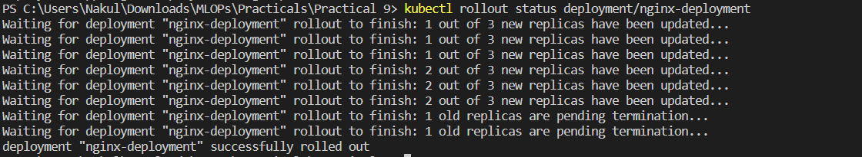

**Step 12:** Rollback Deployment

kubectl rollout undo deployment/nginx-deployment



In this lab, we’ve learned basic Kubernetes commands to interact with a Kubernetes cluster. We've performed operations like creating deployments, services, scaling, updating, and rolling back deployments. These fundamental commands are essential for managing and working with Kubernetes resources in a real-world cluster.